

# Setup Guide

## Initial setup

1. Eclipse (for API on JAVA Spring framework)
2. ZAMP server (MongoDB server, and WebApp server host)

Link: <http://zwamp.sourceforge.net/>

1. Cordova PhoneGap Mobile App setup, you can do this with 2 methods
   1. A. Visual Studio with Apache Cordova CDT and Emulator (Genymotion)

Cordova CDT link: <http://www.microsoft.com/en-us/download/details.aspx?id=42675>

* 1. Apache Cordova, Windows Ant, Android SDK, node, Emulator (Genymotion), and Chrome (testing/console)

1. Install GenyMotion emulator (you might have to register)

<https://shop.genymotion.com/index.php?controller=order-opc>

## API setup

1. Set Apache Tomcat 7 Server [1] in Eclipse

<http://tomcat.apache.org/download-70.cgi>

1. Double click on server, set HTTP/1.1 port to 8081
2. Import “bookaddict.war” on Tomcat 7
3. Download ZAMP, place ZAMP wherever you want
4. Double click on zamp.exe to start the server (This starts MongoDB server)
5. Run the project on Tomcat 7 server

## WebApp setup

1. Download ZAMP, place ZAMP wherever you want (skip this if you already done this in A>4)
2. Place [3] “3 bookaddictWebAppv30” folder in “ZWAMP\vdrive\web” directory.
3. Double click on zamp.exe to start the server (to host angular webapp) (skip this if you already done this in A>6)
4. Open Chrome and browse to localhost <http://localhost/bookaddictv30/index.html>
5. This will show you the home page of app

## Mobile App setup

1. Run command prompt
2. Get your localhost IP address (mobile app require exact address of API localhost)
3. Goto “CODE\bookaddictPhoneGapv30\Bookaddict\scripts\script.js” main script.js.
4. Change the ip address at line 423 & 452 to your localhost IP
5. Run Genymotion (initial setup 4), install “Lollipop Preview – Nexus 5 – 5.0.0 – API 21 – 1080x1920”
6. Start the virtual Device

For Initial setup 3>a

1. Goto “CODE\4 bookaddictPhoneGapv30” [4] folder
2. Run Bookaddict.sln
3. Run the project on Device



For Initial setup 3>b

1. Goto “CODE\4 bookaddictPhoneGapv30\Bookaddict\bin\Android\Debug”
2. Drag and Drop the “CordovaApp-debug.apk” on GenyMotion Virtual Device

## Admin setup

1. Register and search some books either on webapp or mobileapp

Registration email id: “admin@bookaddict.com”

Password: “admin”

You can change this to whatever you want.

1. This will create database structure in MongoDB
2. Open <http://localhost/mongodb/> in Chrome or

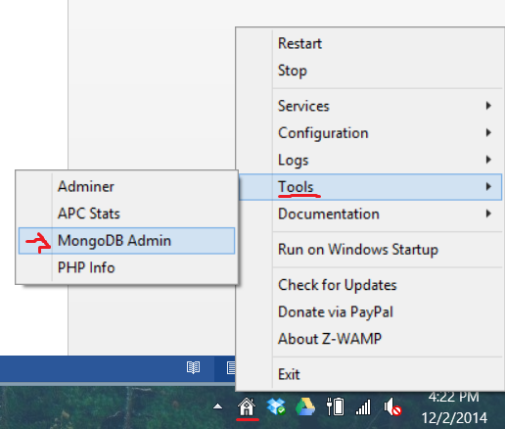

1. Goto “bookaddict” database

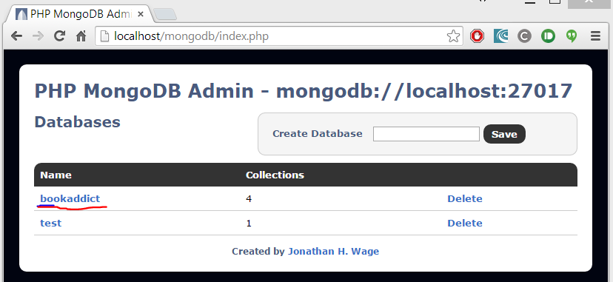

1. Go to “User_Profile” Collection (Collection is a table in NoSQL)

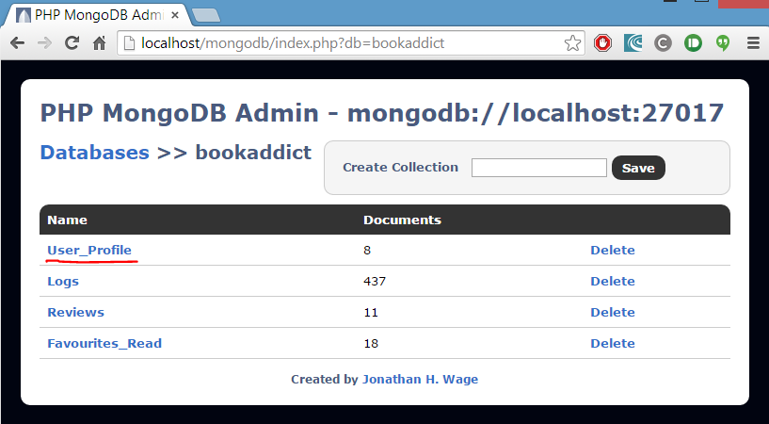

1. Go to “admin” ID

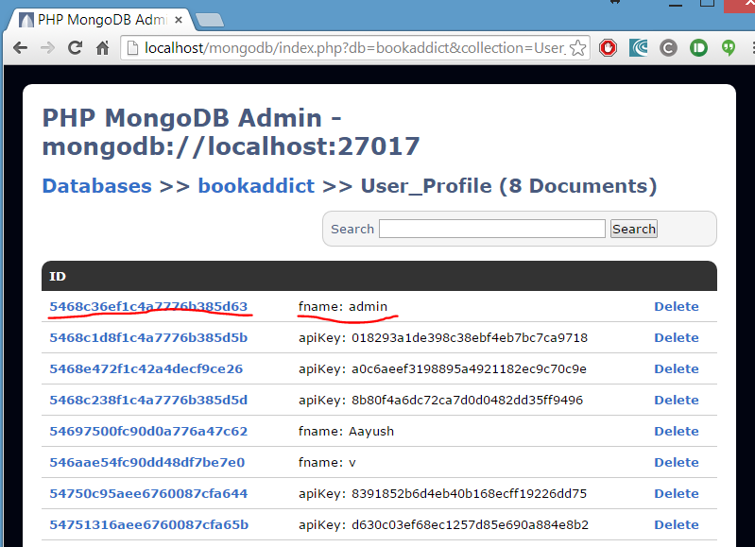

1. Change “userType” to “admin”

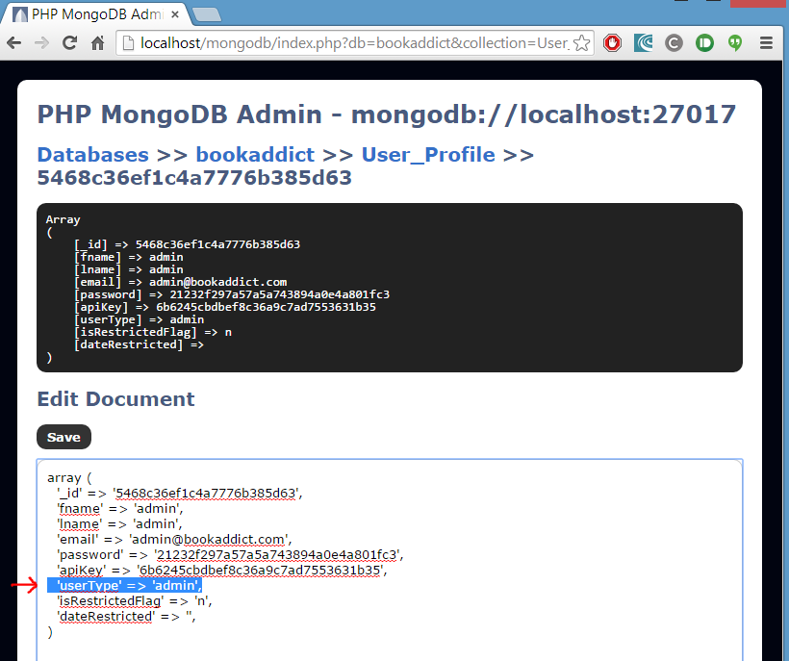

1. This sets this user as admin, who gets the right to manage other users.

### Java Doc

JAVA doc can be found on [5] “CODE\5 JAVAdoc\index.html”

### API Documentations

API documentations can be found on WebApp footer

Thanks for using BookAddict APIs

​

Regards

**Gaurav Gaikwad**

Email: [gauravgaikwad777@gmail.com](mailto:gauravgaikwad777@gmail.com) | Phone: +1 (309) 750-5556

**[LinkedIn Icon2](http://www.linkedin.com/pub/gaurav-gaikwad/39/859/566) [ GitHub](https://github.com/gauravgaikwad777)**

**Scott Weathered**

Email: [s.weathered@gmail.com](mailto:s.weathered@gmail.com) | Phone: +1 (630) 338-3782